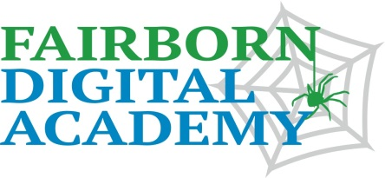
STUDENT PROFILE October, 2013
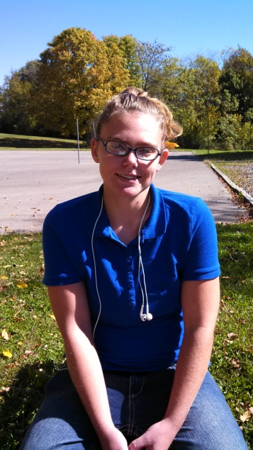
Peggy Marie Dickerson
Peggy Dickerson is a 10th grader at Fairborn Digital Academy whose favorite subject this year is science. Peggy especially likes learning about the periodic table of the elements. Last year, she didn’t understand the elements, but now she knows that, since everything in the world is made of the elements, learning about them is very interesting.
Peggy’s favorite experience at the school is getting to see her teachers. She has especially appreciated help she has received from Mrs. Brown, Mrs. Dixon and Mr. Waterman. “Mrs. Brown is really good at math, and she is my home room teacher. Mrs. Dixon is fun to talk to. And Mr. Waterman always helps me with my reading,” she explains. Peggy says her mother, Judy, is glad she is doing so well at FDA. “I love my family most of all!”
Since Peggy is now in her third year at FDA, we asked her how she has changed since she started. “Reading – I used to struggle with reading. But now I can read The Witch and the Wizard. And that’s fun because I really like fantasy. I think it’s much easier to read when the subject is interesting.”
What does Peggy want to do when she is finished with high school? “I definitely want to work with my hands. I like taking things apart and putting them back together. I love to help my mother put furniture together when it comes in a box and you have lots of parts.”
Then her eyes brighten. “Oh -- I am very interested in sign language, which is also working with your hands.” Peggy explains that she went to Panama City with her church group and took lessons in signing. “You can learn how to communicate with people who can’t hear, and that is helping people,” she said. Peggy says she might want to be an interpreter one day. If there were one more class she could take, it would be sign language. At the end of our session, Peggy gracefully motioned with her hand, the sign: “Thank You.”

